JOB DESCRIPTION

Office of the Auditor General

Job Title: PROFESSIONAL AUDIT TRAINEE
Grade: L
Salary Range: CI$53,616 - $70,344
Reports To: Audit Manager

JOB PURPOSE

Professional Audit Trainees assist the Audit Managers and the Auditor Project Leaders in carrying out their responsibilities in accordance with the powers and duties specified in the Constitution and the Public Management and Finance Act (PMFA).

Post holders will assist with a portfolio of audits of various government ministries, portfolios, offices, statutory authorities and government companies. These audits are conducted following International standards on auditing. The types of audits conducted include financial, performance, compliance, IT, fraud and special audits.

The Audit Trainee may also undertake some administrative tasks to support the OAG in the delivery of its corporate operations.

DIMENSIONS

The responsibility of the Office of the Auditor General (the “OAG” or “Office”) includes auditing the revenues and expenditures of core Government that are approximately $1 billion respectively and total assets of $2.7 billion, as well as statutory authorities and government companies with revenues of $240 million and total assets of just over $500 million. The OAG conducts 45 to 50 entity financial audits and 6 to 8 performance audits each year, along with the entire public sector (EPS) consolidation audit, and other unscheduled special audits and investigations as required.

The role of the Professional Audit Trainee is heavily dependent on the use of computer systems for both reporting purposes as well as audit analysis.

BACKGROUND INFORMATION
The Office of the Auditor General is the independent “watchdog of government spending” working on behalf of Parliament and the wider public. It carries out the following lines of work:
- Financial Statement Auditing – establishing that the financial statements are a fair representation of the financial position of the audited body thereby playing a crucial role in improving standards of financial management and administration throughout the diverse range of public service entities involving several complex accounting issues;
- Performance Auditing – involves business evaluation, reporting and advising through the evaluation and audit of any aspect of public service/ government operations, checking that resources are purchased economically, used properly and that effective management systems and controls are in place;
- IT Auditing – the main objective is to determine whether information systems are being effectively managed, safeguarding the entity’s assets against actual and potential misuse, maintaining data integrity, and operating effectively and efficiently to achieve the organisation’s goals or objectives;
- Forensic Auditing – facilitates the prevention, detection and investigation of economic crime.
- Compliance Auditing – ensuring compliance with Acts, regulations, policies etc is usually undertaken within a financial or performance audit. Specific compliance audits are undertaken as necessary e.g. when needed to confirm grant funding is used as per the requirements of award.

PRINCIPAL ACCOUNTABILITIES

- Assist in the planning of audit engagements by gaining an understanding of the entity’s objectives, structure, policies, processes, and internal controls.
- Assist in developing audit schedules.
- Complete audit work papers by documenting audit tests and findings.
- Communicates audit progress and findings by providing information in status meetings and identifying discrepancies.
- Updates job knowledge by participating in educational opportunities and obtaining professional accounting designation as supported by the Office;
- Contributes to team results by helping others accomplish related job results as and where needed.
- Assisting in the testing of data to determine accuracy, currency and reliability and develops reports utilizing a range of techniques including, but not limited to, statistical sampling and quantitative analysis.
- For financial audits assist in determining whether financial information conforms to the generally accepted accounting principles to produce audited financial statements and disclosures to form audit opinions.
- Prepares audit working papers in accordance with professional standards to provide adequate documentation for audit findings, conclusions, and recommendations.
- Assist in the preparation of final audit reports.
- Delivers finance and administrative tasks to support the running of the Office of the Auditor General.

KNOWLEDGE & EXPERIENCE

Knowledge
Essential
- a university degree (bachelor's) in a relevant field.
- computer literate with the ability to use MS Office products.
- Enrollment (or intent to enrol) in a professional accounting program (e.g. CPA, ACCA).

Desired
- Ability to use CaseWare or similar audit working paper software program and IDEA.
- Knowledge of public sector governance and management concepts.

Experience

Desired
- Experience working in a professional office environment.
- Experience of working in a public sector finance role in the Cayman Islands.

SKILLS AND Competencies
The Audit Trainee must possess and demonstrate:-
Deliver Quality Services
- Achieves Results - Ability to plan and deliver quality audits on time and within budget.
- Analysis - Ability to gather and understand information, evaluate existing situations and plan ways forward, solving problems and achieving outcomes.
Effective Stakeholder Engagement
- Communications - Good oral and written communication and presentation skills including the ability to actively listen.
- Manage Relationships Effectively - Ability to build strong respectful relationships and challenge constructively.
Leadership and Management
- Self-Management - Take responsibility for own actions and development, exemplifying personal drive and integrity while continuously developing.
- Resilience - Ability to work independently and under pressure.
Judgement and Decision Making
- Critical Thinking - Curiosity, professional skepticism and awareness of political contexts in approaching tasks and problems.
- Change Orientation – Ability to accept and respond positively to changing work situations and demands.
Contribute to the Value and Benefit of OAG
- Team Working – Ability to work effectively as part of a team and contribute to building a stronger OAG.

assignment and planning of work

Audit Trainees are assigned to assist on a range of financial and performance audit work and may be assisting on at least two or three audits and core OAG work at any time. Audit Trainees may work on small audit engagements by themselves. Audit Trainees may also support the Office’s corporate services.

SUPERVISION OF OTHERS

The OAG has an establishment of 29 staff, including professionally qualified and experienced accountants. The Audit Trainee will not be required to supervise others until at least part qualified when interns and other audit trainees may be supervised.

GRADE PROGRESSION

Without exception, Audit Trainees will be appointed to Grade L. Ordinarily this will be to point 2 on the grade as per Government policy. However, an appointee may be placed on a higher point if they have relevant audit experience, are already part qualified, or have academic qualifications that result in professional exam exemptions.

Audit Trainees career and pay progression will be in accordance with the OAG Trainee Study and Progression policy. On passing all professional examinations, the trainee will progress to Grade I (Audit Project Leader).

OTHER WORKING RELATIONSHIPS

The Audit Trainee is required to maintain a professional working relationship with all stakeholders from public and private sector organisations in the delivery of the OAG’s audit programmes and services.

DECISION MAKING AUTHORITY AND CONTROLS

The Audit Trainee works primarily under the general supervision of the Audit Managers and Audit Project Leaders. No specific decision-making authority is assigned to the Audit Trainee.

PROBLEMS/KEY FEATURES

The post requires an individual who can work under pressure to meet deadlines and balance many roles concurrently.

The work of the OAG is of high public profile, with considerable press and public interest.

WORKING CONDITIONS

Due to the complexity and quantum of assignments, additional working hours are required on occasion for which overtime may be payable.

Due to the geographical location of clients, some travel may be required to complete engagements.

ORGANISATION CHART

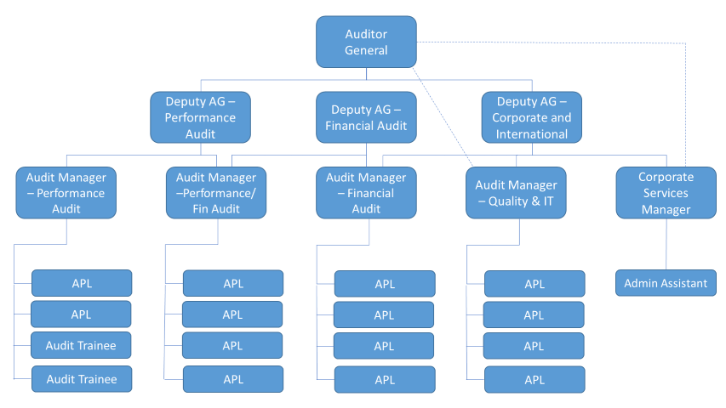

AGREED BY:

Professional Audit Trainee: Date:_________________________

Auditor General: Date:

